# Node JS notes:

## ***Module:***

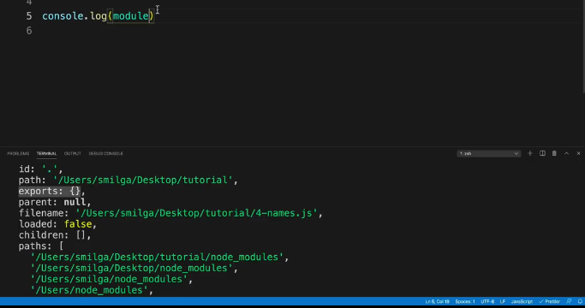

Properties of the module

* Refers to the JS file and its default properties (id, path, parent, exports etc.)
* The Export properties is used to pass through data such as Functions and variables

## ***Built-in Node Modules:***

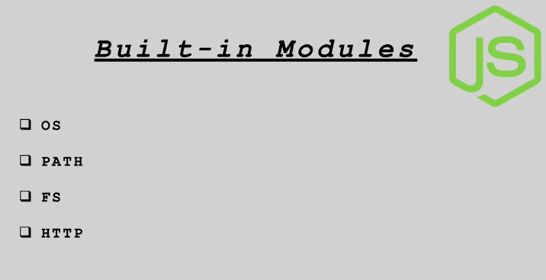

* Are useful modules pre-built for convenience
* Can be utilized to make projects more efficiently
* OS module evokes methods referring to the OS
* PATH module evokes methods to manipulate file Paths
* FS module evokes read and write methods in sync and async
* Http Modules evokes



### Module used to create the local server

## NPM (Node Package Manager)

